Go to <https://git-scm.com/downloads> and click on Download for Windows.

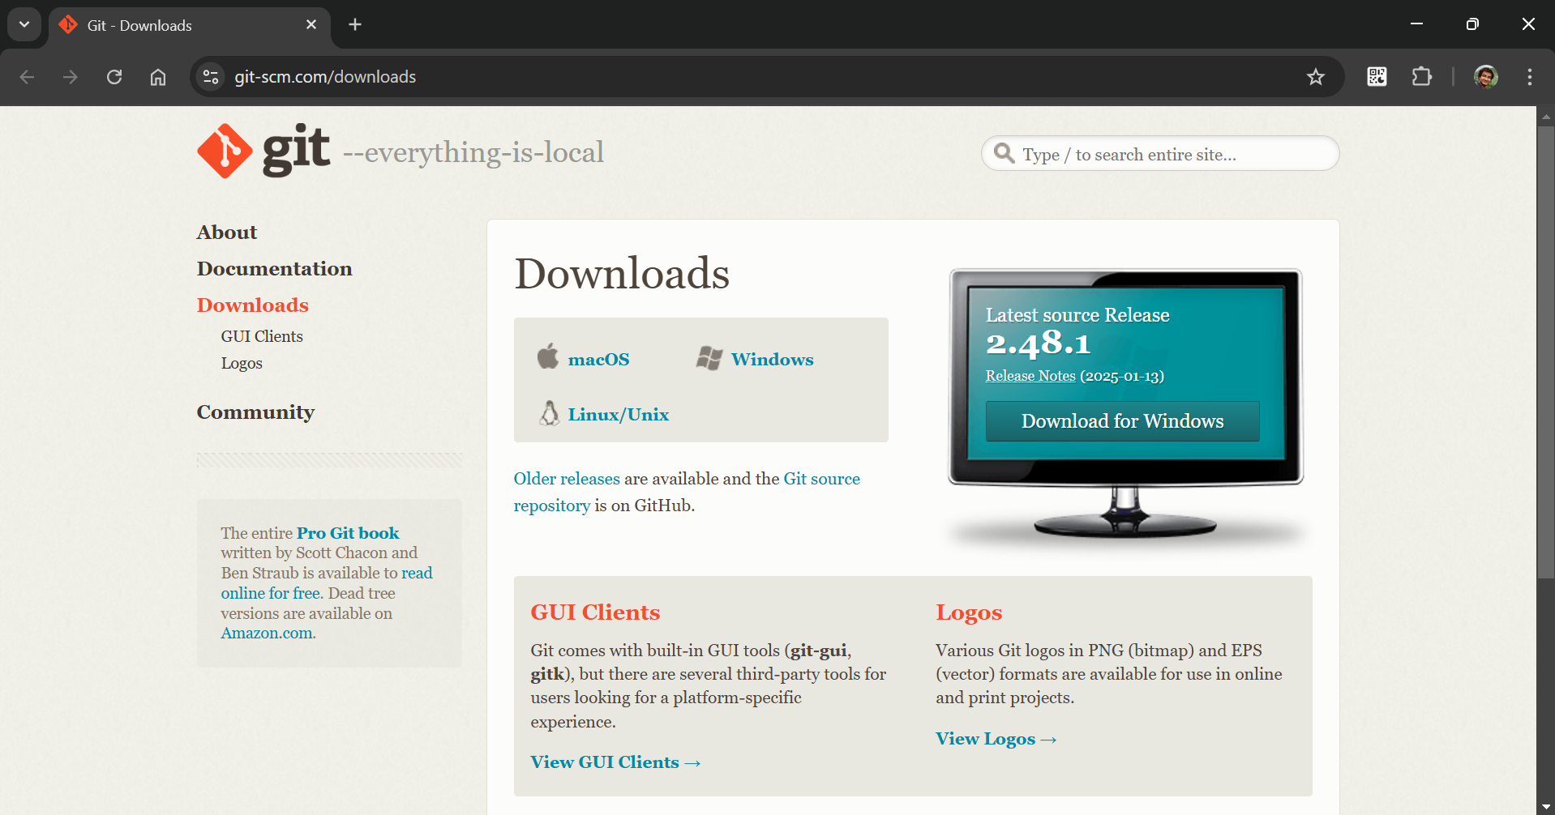

Click on Click here to download

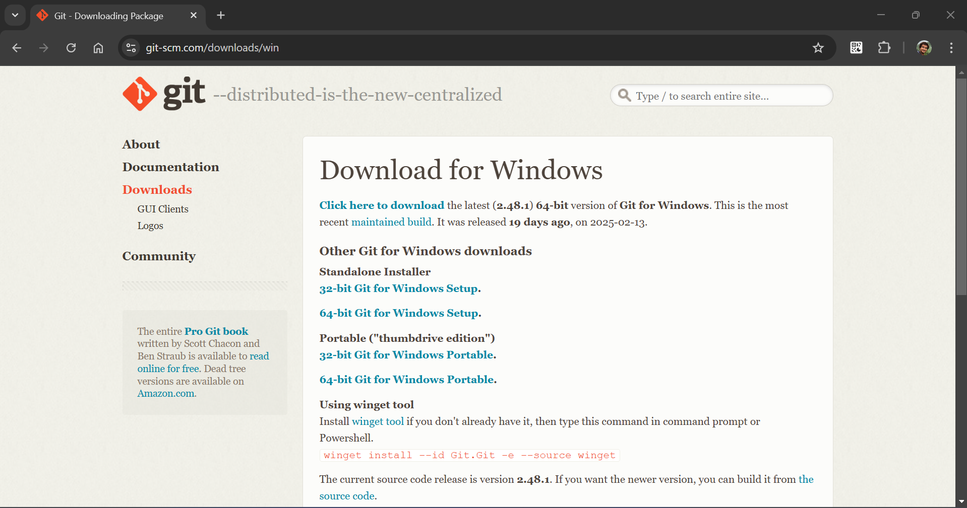

After downloaded double click on git exe file then click on Install

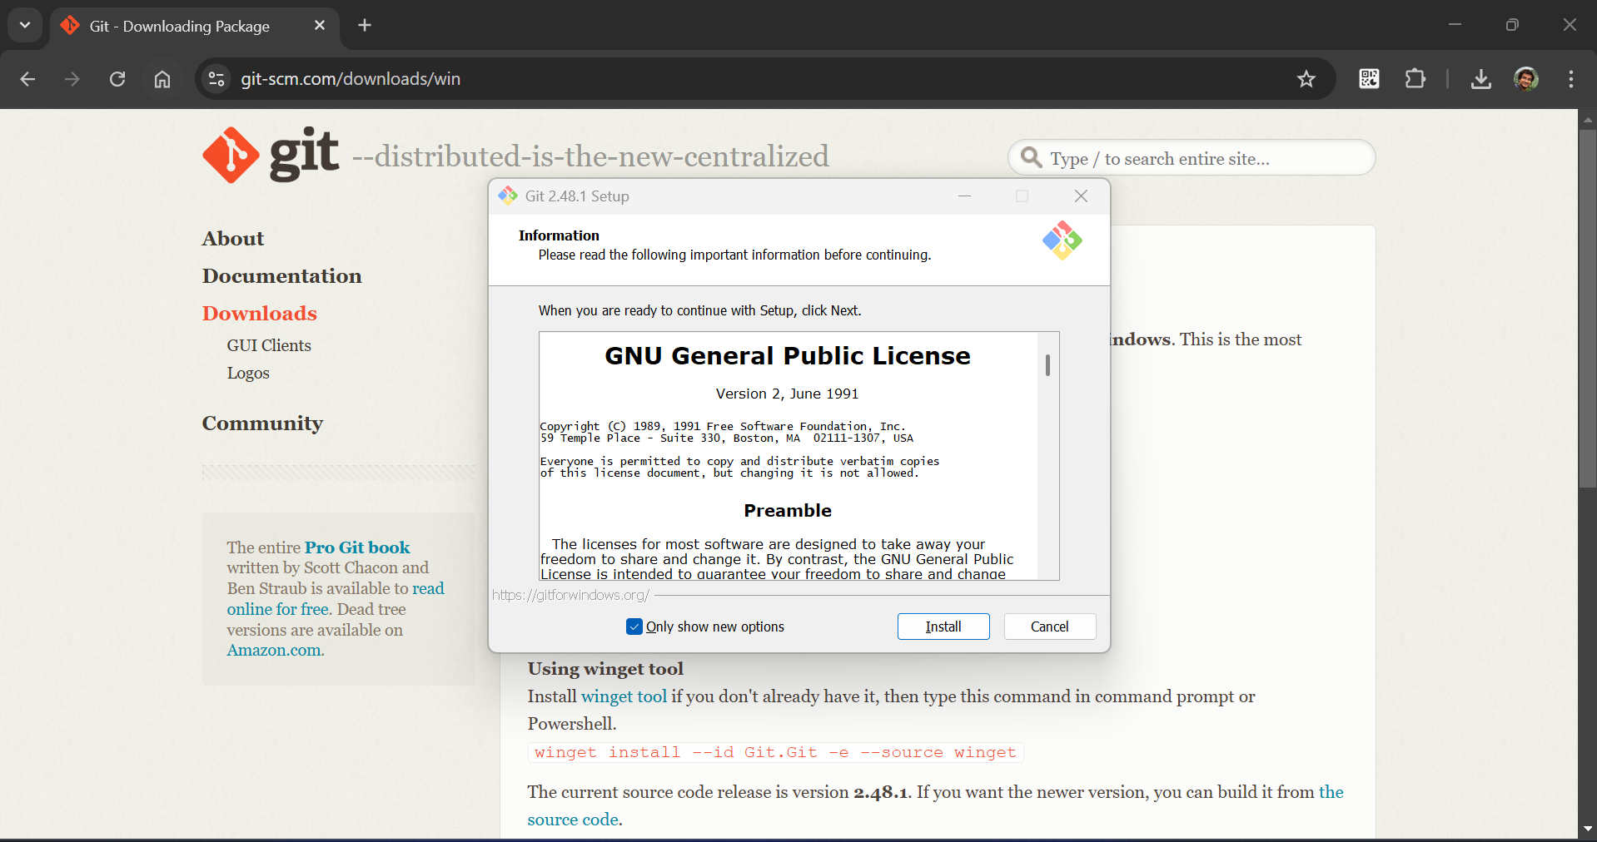

Click on Finish to complete installation

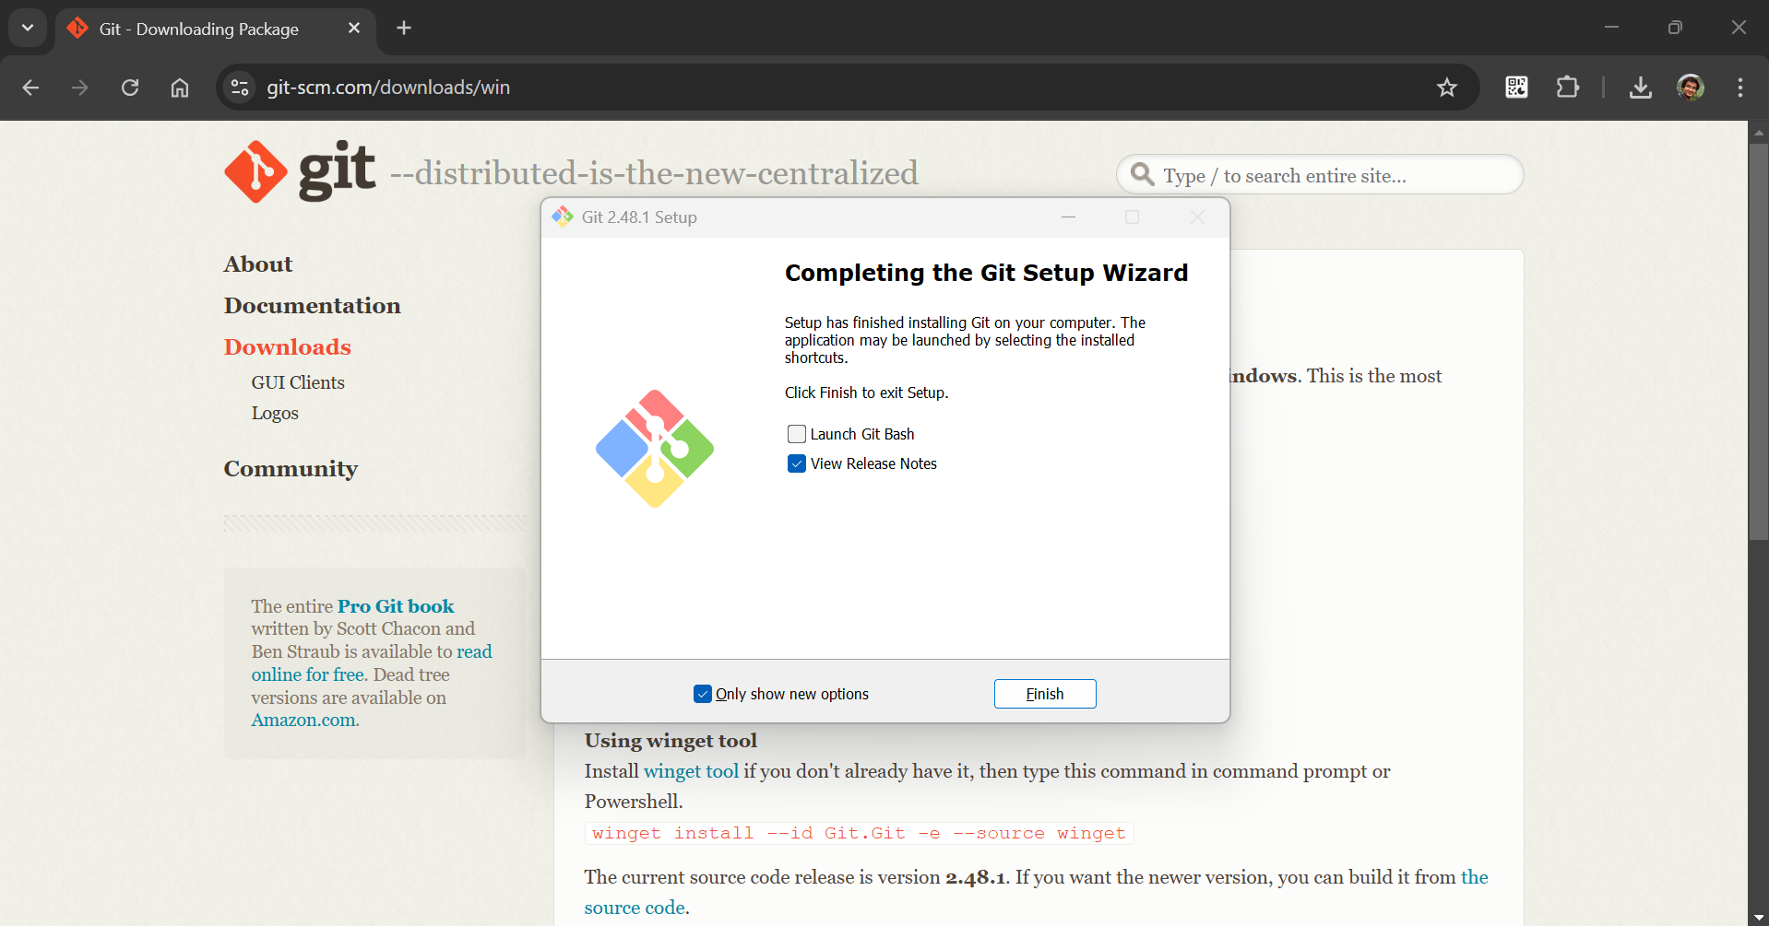

Open Git Bash enter below command to configure user name and hit enter

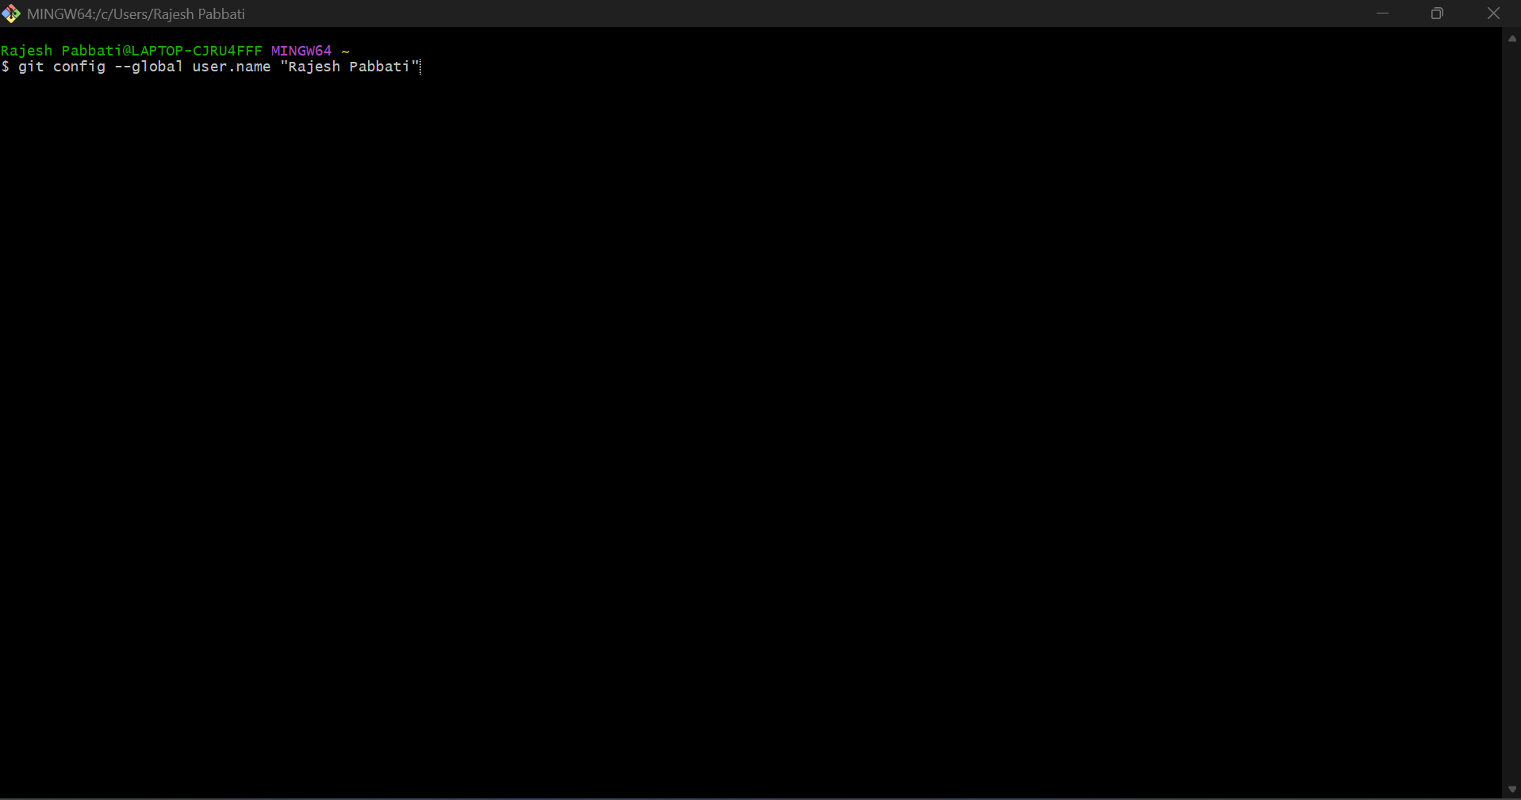

Enter below command to configure user email and hit enter

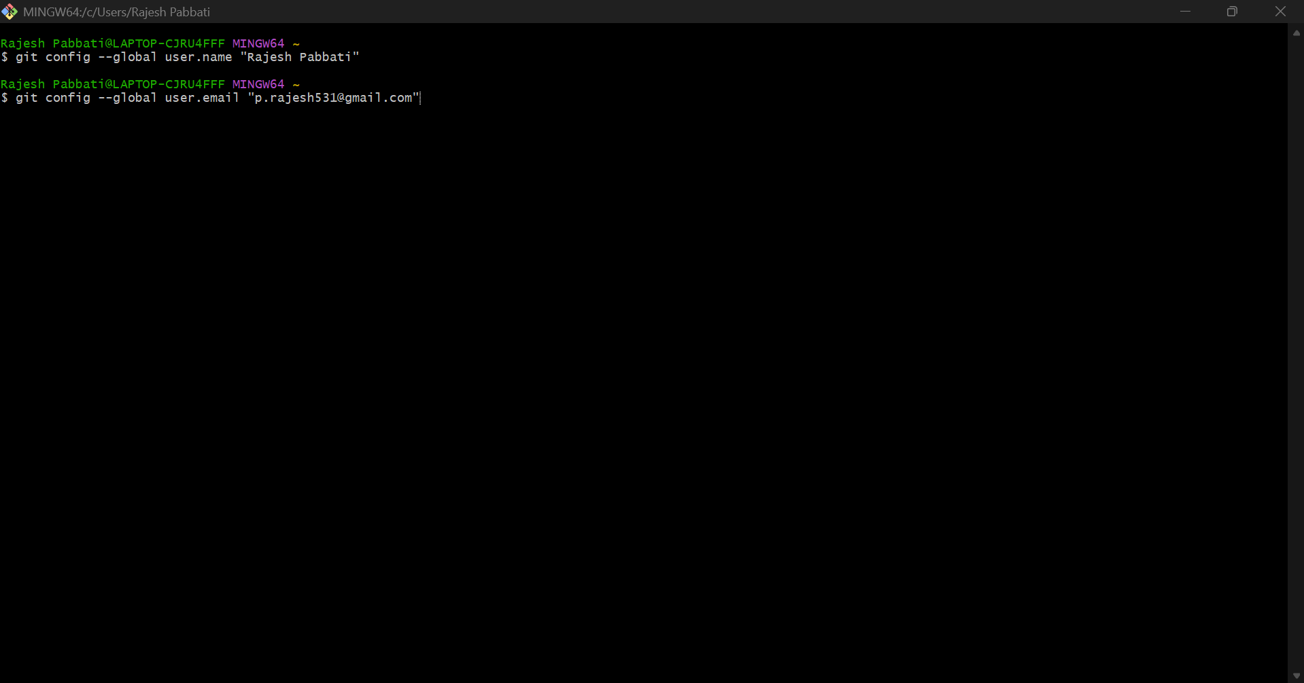

Enter below command to check configure user name and user email

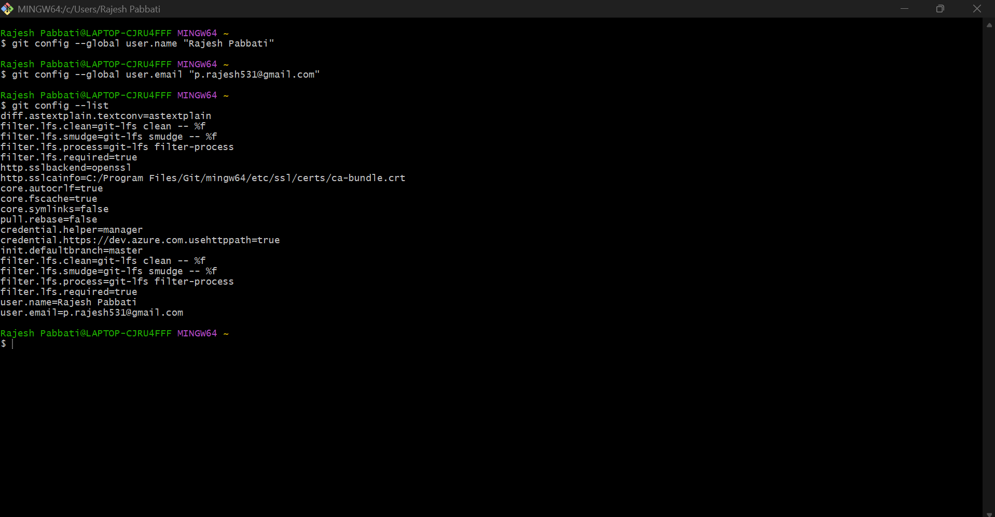

Etner below command to check git version. If it shows version then git is installed properly.

